**AWS RDS contd ….**

* Lets create a rds instance <https://directdevops.blog/2022/05/18/aws-classroomnotes-18-may-2022/>
* Ensure you have backups for atleast 2 days.  
  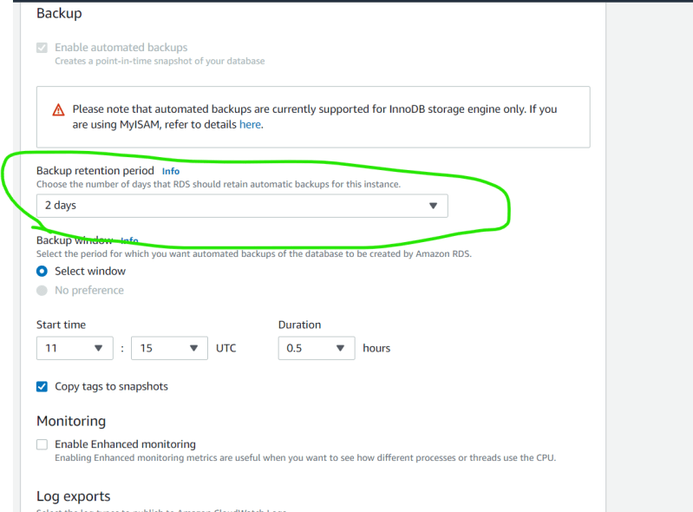
* Lets create a read replica  
  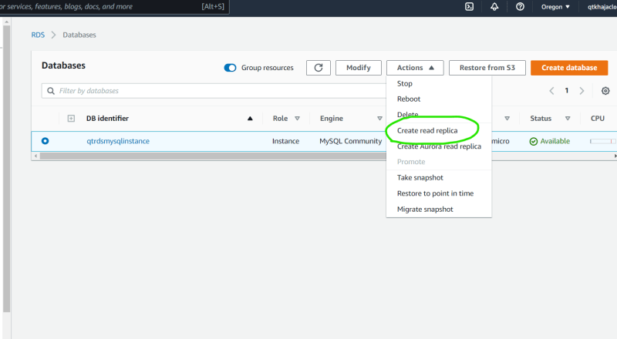  
  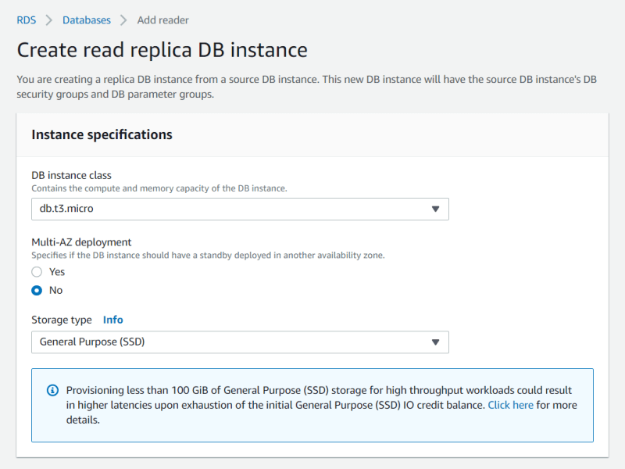  
  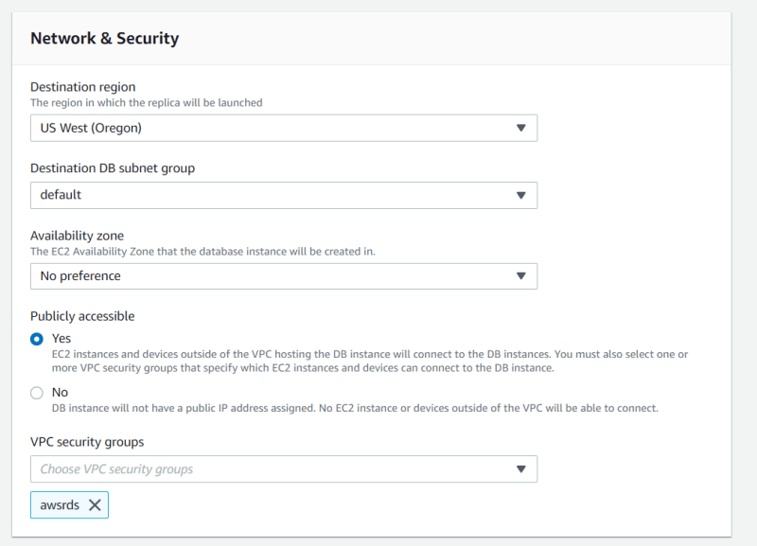  
  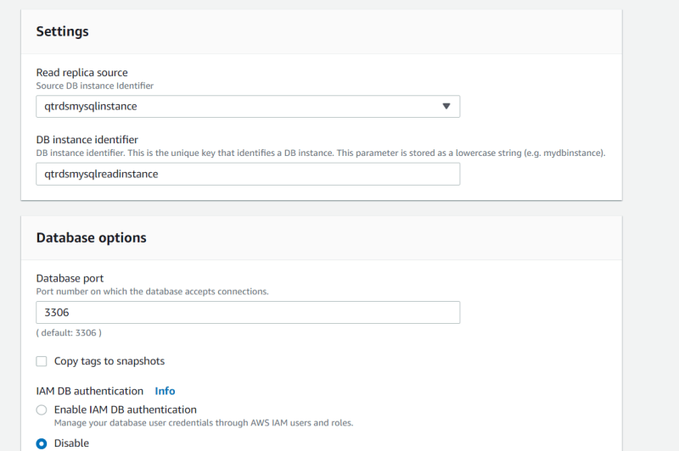  
  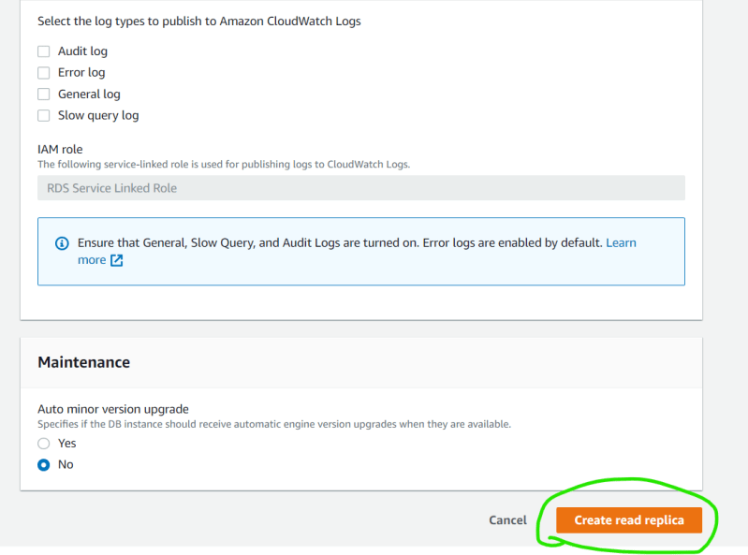  
  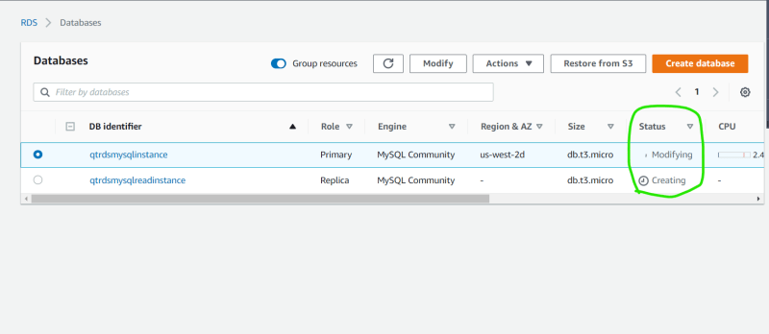  
  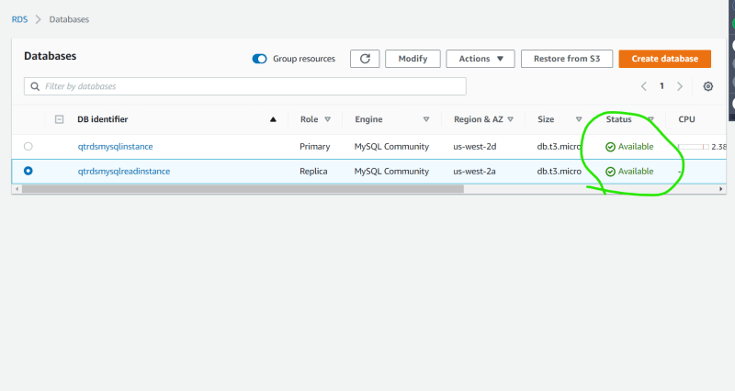
* Now lets login into primary instance and query the data  
  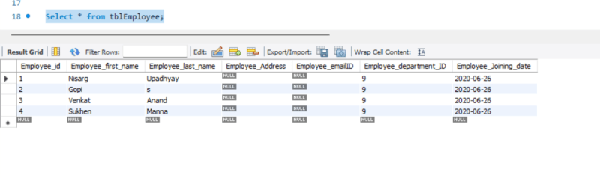
* Now lets login into the replica instance and query the data  
  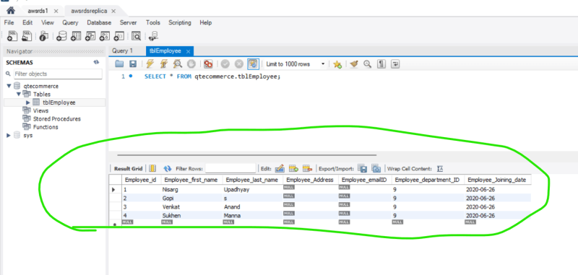
* Now lets insert one record in primary instance  
  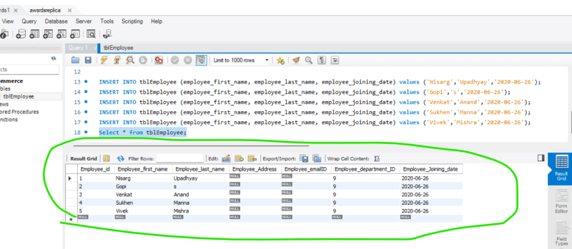
* Lets check for the new record in the replica instance  
  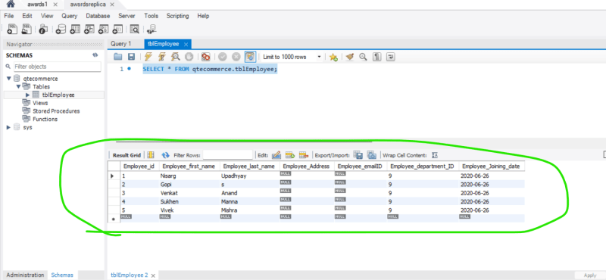
* Lets try to insert the record in the read replica  
  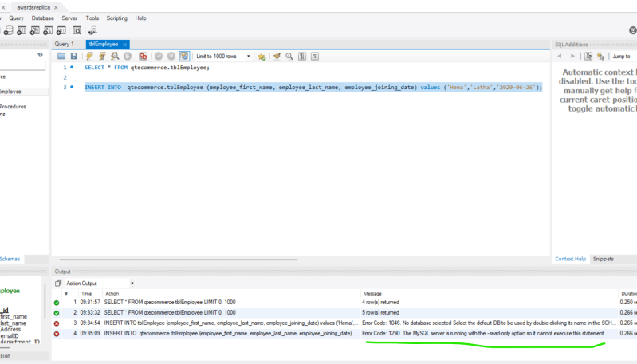
* Why read replica?  
  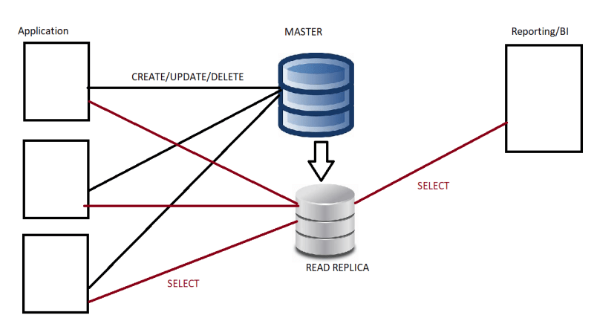
* At any moment if your master is down you can promote the read replica to allow insert operations  
  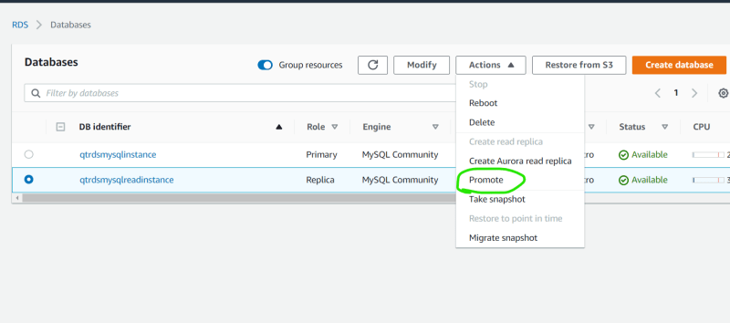
* Delete the read replica
* Exercise: Create a rds instance with postgresql and create a read replica and delete every thing.